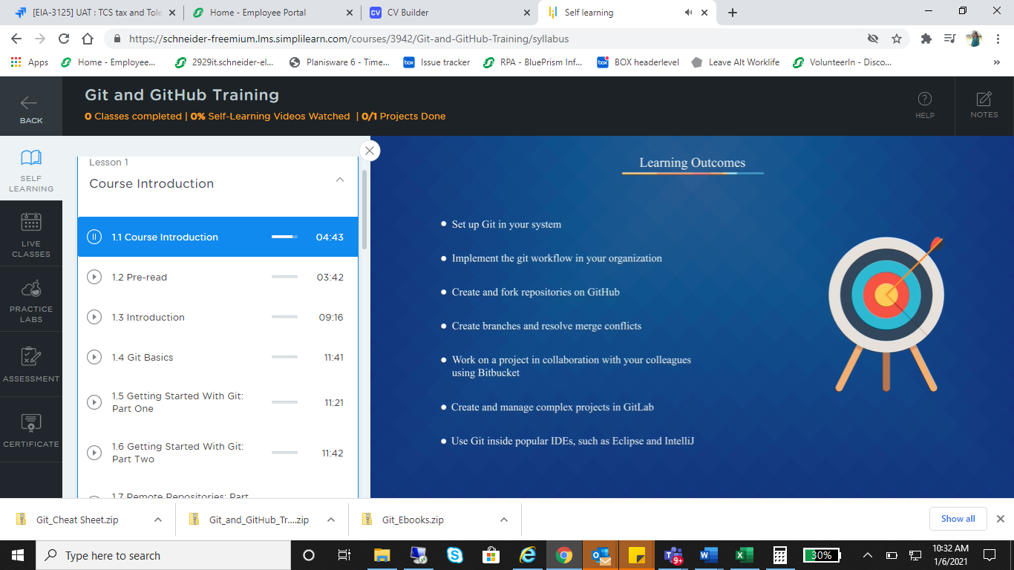

PLAN – Jira/Git

CODE – github/gitlab

BUILD- docker/gradle/maven/chef/ansible

TEST- selenium , junit

DEPLOY- puppet , chef, docker

OPERATE- splunk

Integrate-. jenkins

MONITOR

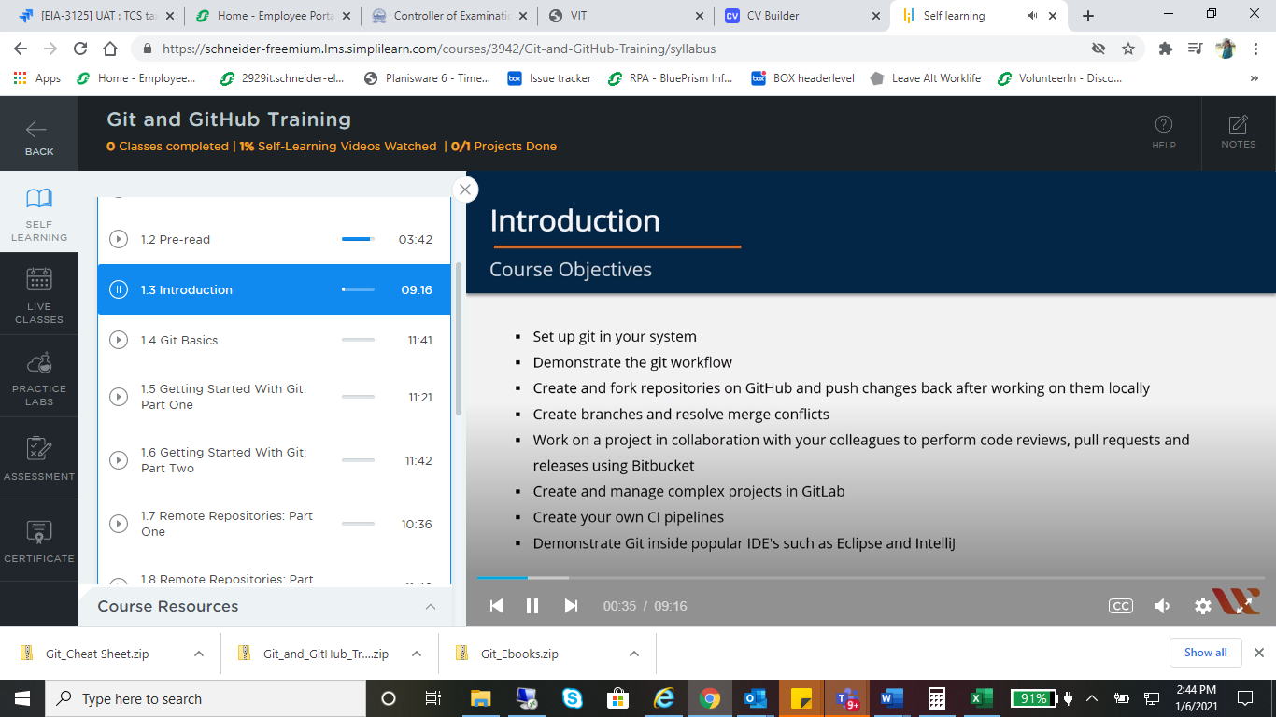

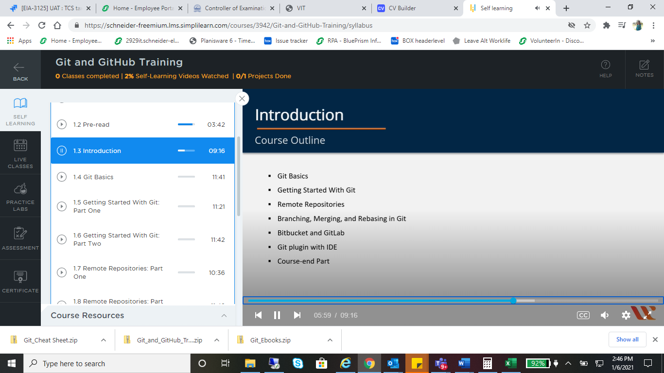

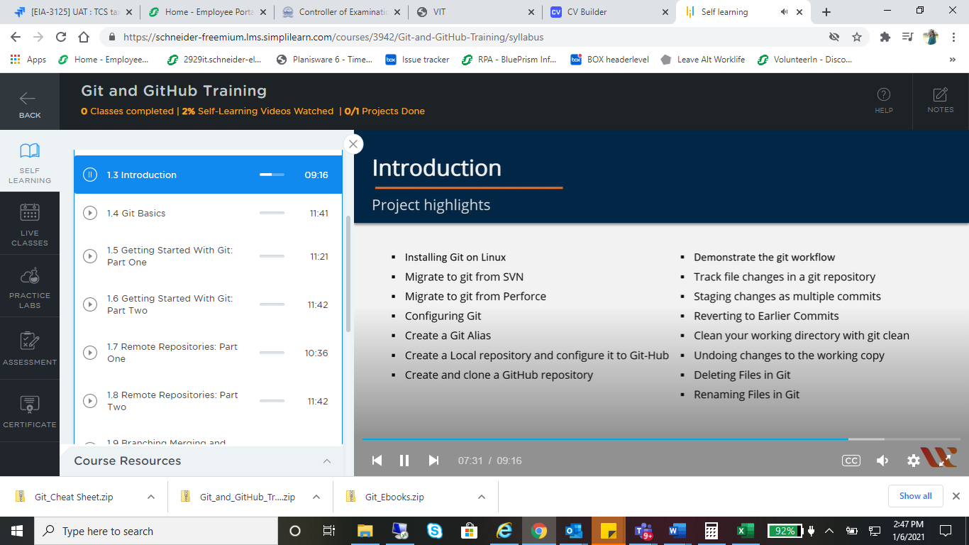

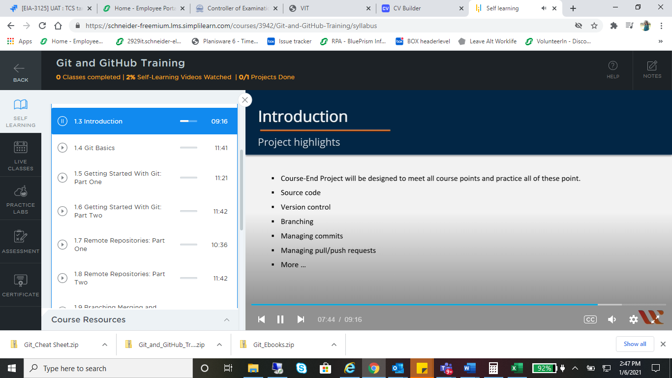

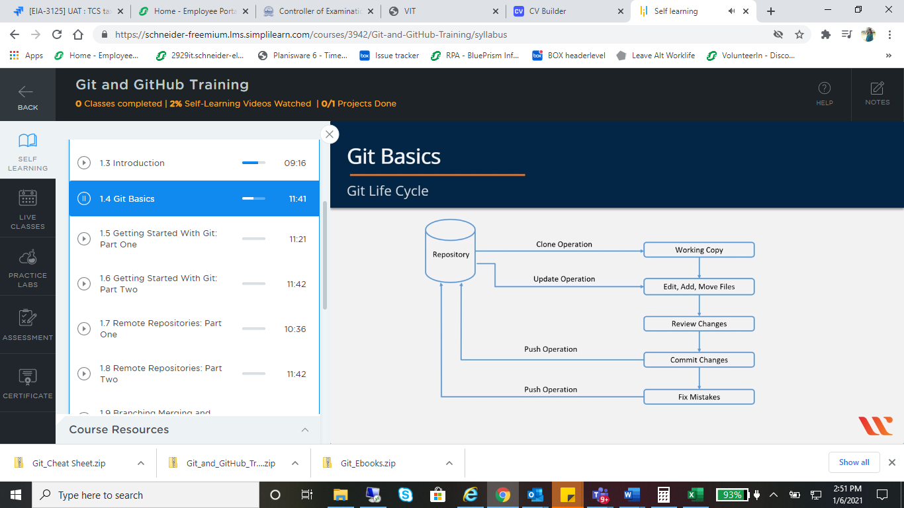

Installing git in Linux OS

Yum install git

Su -> switching to root user

Git config -l : to list current config

Git config –global user.name “git2..”

Git config –system core.editor vim

Cat ~/. Gitconfig : to view alias

Repository :

Bare and non -bare

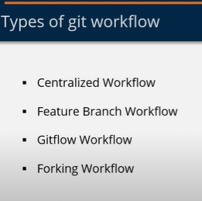

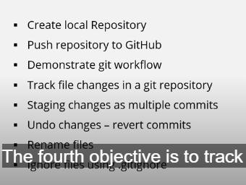

Mkdir project name

To create git repo:

Git init

Pwd

Ls -al : already created repo

Vim firstfile

Git add

Git push -u origin master